Calculus 3 Lecture 11.1: An Introduction to Vectors

Vector have both a speed (Magnitude*) and direction (on a co-ordinate system)

*given by the length of a vector (magnitude)

Example
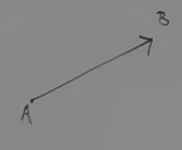
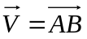

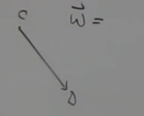
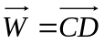

* can multiple a vector by a constant. (constant is called a scalar)
- Scalars can change length of a vector.
- Can reverse direction of a vector.

Example

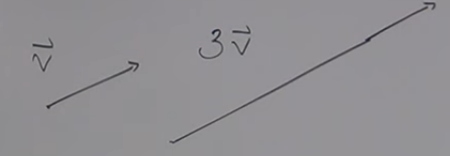

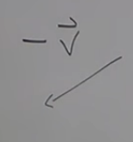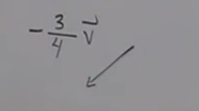
Scalar multiples of a vector are always paralell

Adding and subtracting vectors
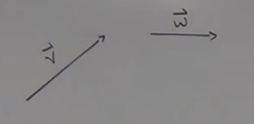
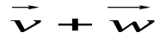
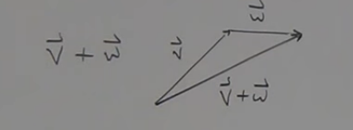

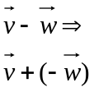

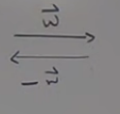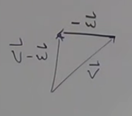

A vector 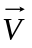 with an initial point at the origin and a terminal point at 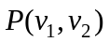 is called a position vector of and is denoted 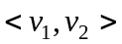 (goes from origin to point)

*** ANY vector can be translated to a position vector.

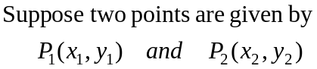
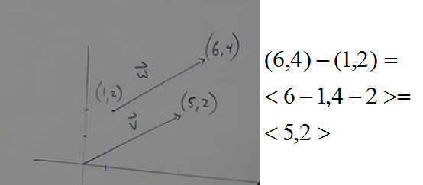

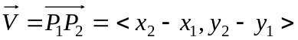

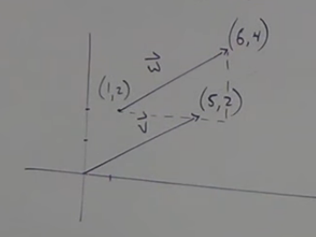

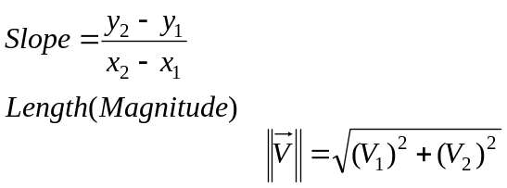

To determine if two vectors are equal compare slopes and magnitude.
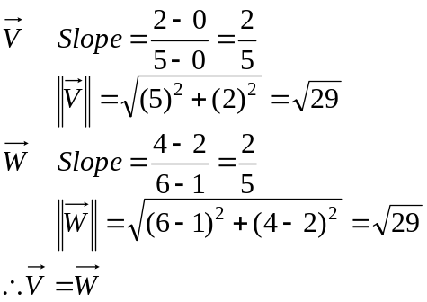

Or change each vector to a position vector Notation.
Subtract terminal point from intial point to give position vector notation.
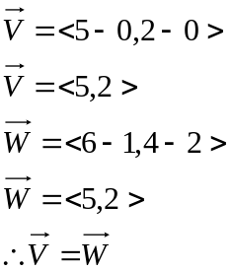

Working with Position Vectors
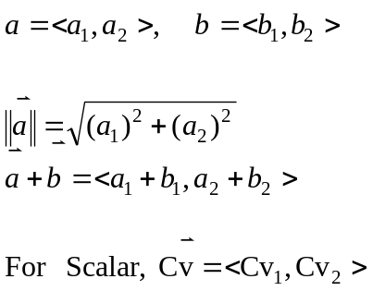

Example
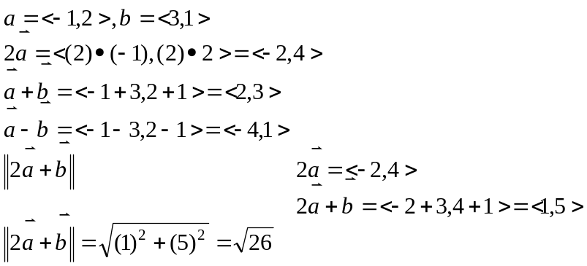

Unit Vectors
A vector with length or magnitude of “1” is called a unit vector,

You can change any vector into a unit vector.
To find a unit vector from any position vector divide by the magnitude.
Unit vectors get a party hat for notation. 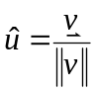
*we can define a vector as magnitude *(unit vector) Direction 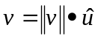

Example
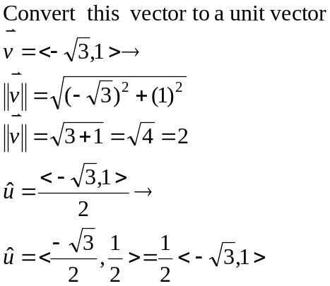
Find a unit vector in the opposite direction of
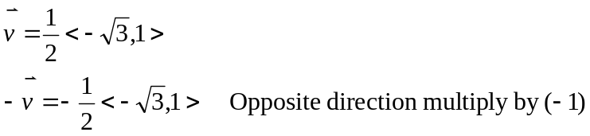

Standard Basis Vectors

The standard unit vectors are

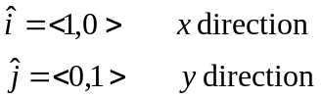

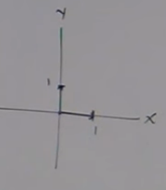

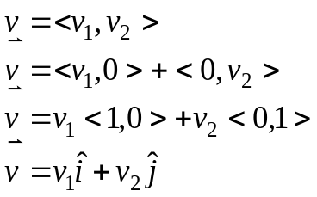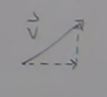

Example
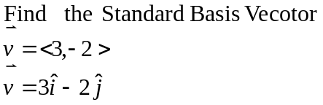
Example
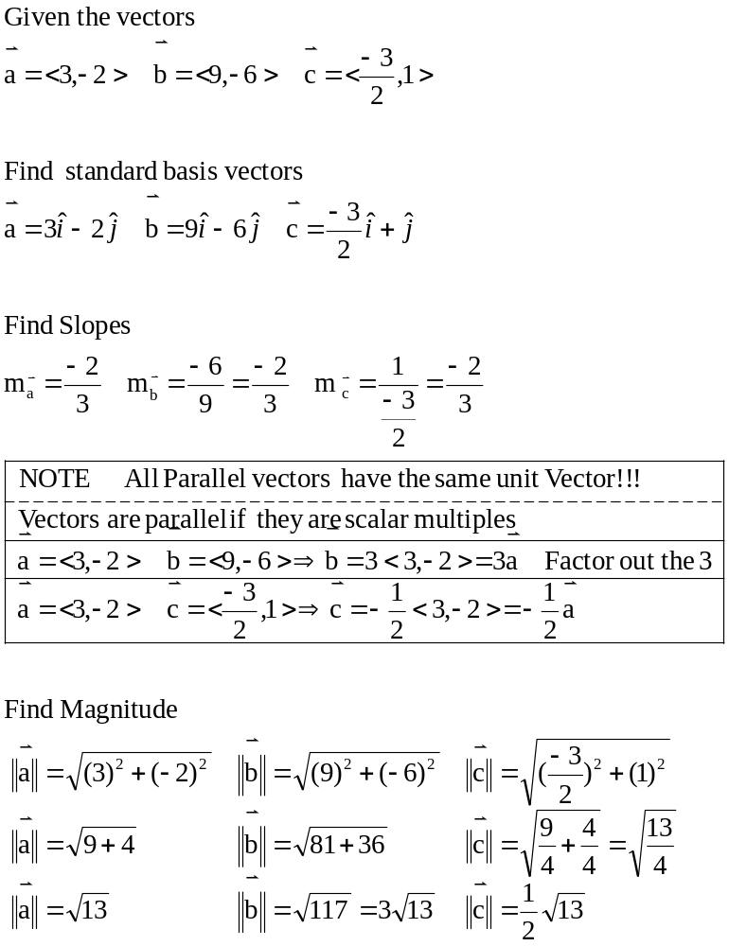
Example
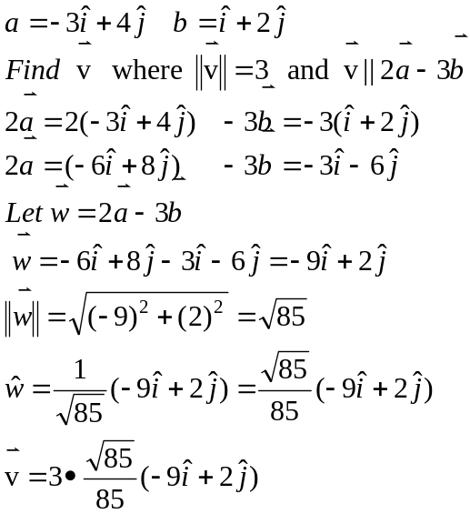

A unit vector will have a terminal point on a Unit Circle

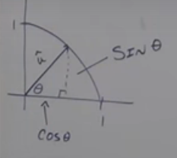

You can find the unit vector if you know the angle
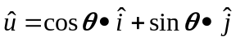

Example
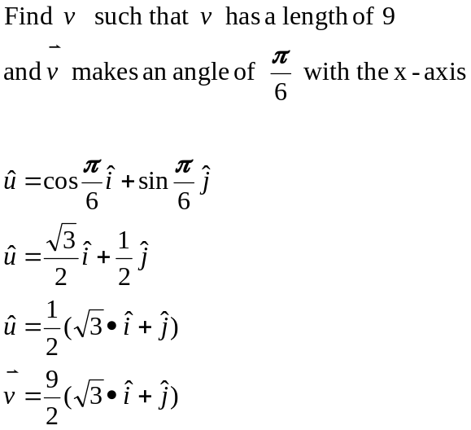

Example
Find the vectors:
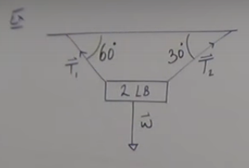

Forces need to be equal and opposites (Newtons 3rd law)
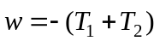

Draw x-y axis on diagram above to help better get a grasp on the angles involved.

